Dear 2Oth Ward Neighbors,

Thank you to each resident who took the time to participate in the 20th Ward Liquor Moratorium voting process to determine whether Alderwoman Taylor should lift any of the liquor moratorium districts across the Ward. Our Ward has more than 600 active moratorium districts passed by the City Council before Alderwoman Taylor's first election in 2019.

We take your concerns and feedback very seriously and have verified that two of the current liquor moratorium districts will be amended to permit the transfer of packaged goods licenses to non-family members at the following businesses:

1. Mr. G's Food & Liquor at 332 East 58th Street, **see****Municipal Code: 4-60-021 (20.19)**. This amendment will lift the moratorium district "on 58th Street, from Indiana Avenue to Dr. Martin Luther King, Jr. Drive."

2. Grove Market at 6656 South Cottage Grove Avenue, **see Municipal Code: 4-60-021 (20.152)**. This amendment will lift the moratorium district "on the west side of Cottage Grove Avenue, from Marquette Road to 68th Street."

Alderwoman Taylor wanted 20th Ward residents to be able to weigh in on whether any liquor moratorium districts should be lifted or amended. We started planning a Ward Night on the topic last fall, engaging the Department of Business Affairs and Consumer Protection leadership, Community Policing across our four police districts, and three other alders and Ward Offices on their experiences lifting moratoriums. Ward Staff followed a similar community outreach plan as we expect from developers seeking zoning amendments by conducting two months of strategic community. Over thirty-five Ward 20 residents and local business owners attended the community meeting. A total of **212** votes were cast during the 7-business day voting period held after our.

Please check your email for future announcements about the upcoming Plan of Operation meetings hosted in partnership with BACP, CPD, and the new owners of both of these businesses. The final votes are on the following page along with a list of Frequently Asked Questions.

Jeanette B. Taylor,

20th Ward Alderwoman

Tyra Owens,

Deputy Chief of Community Planning and Economic Development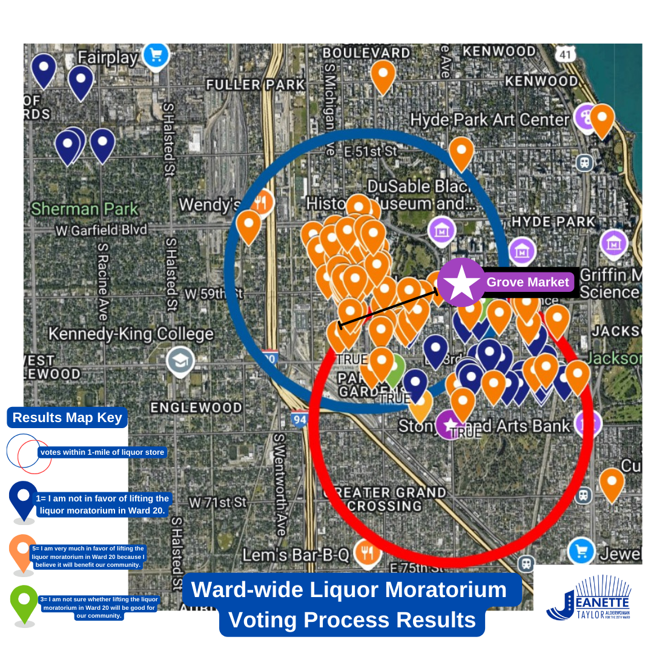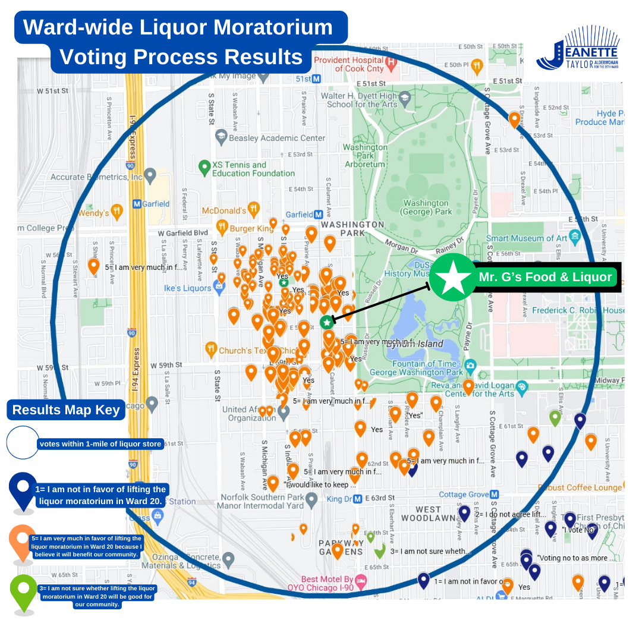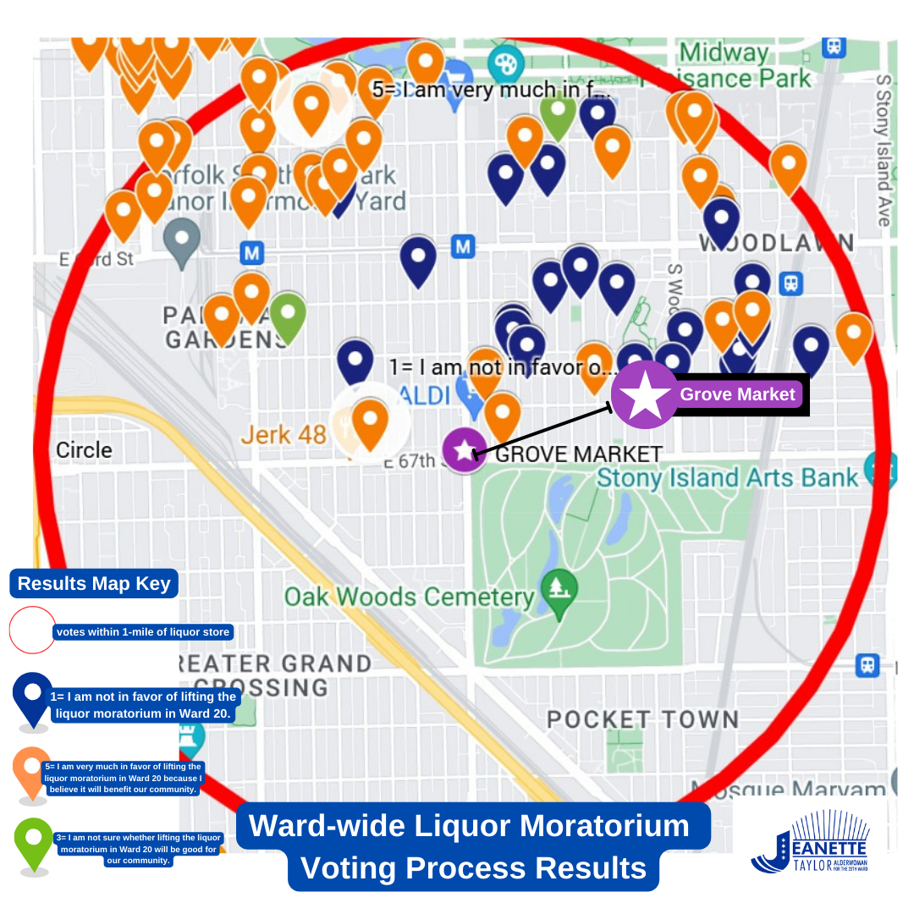

**Frequently Asked Questions: Liquor Moratorium Districts**

Q: How do I verify if there is a moratorium district in my neighborhood?

A: The vast majority of liquor moratorium districts that currently exist across Ward 20 can be found on residential blocks. Two no-cost tools for residents to use that will verify whether there are any moratoriums near them include 1) the [Municipal Code](https://codelibrary.amlegal.com/codes/chicago/latest/chicago_il/0-0-0-2616809) which outlines each moratorium district across Ward 20, and b) requesting help from [Business Affairs and Consumer Protection](https://www.chicago.gov/city/en/sites/chicago-business-licensing/home/liquorlicenses.html).

To view the current list of moratorium districts, click here: <https://codelibrary.amlegal.com/codes/chicago/latest/chicago_il/0-0-0-2616809>

Q: What are the various Liquor License Restrictions?

A: There are six different types of liquor license restrictions. To read more about each of them, click the following link: <https://www.chicago.gov/city/en/depts/bacp/supp_info/liquor_license_restrictionsandspecialregulations.html>

Q. What is a packaged goods license and its requirements?

A: Packaged Goods License: This license is necessary for the retail sale of alcoholic liquor enclosed in the original manufacturer's sealed and labeled container. Businesses requiring a packaged goods license include grocery stores, convenience stores, and liquor stores. Businesses that sell packaged goods are not permitted to sell alcohol to be consumed on the premises. Tasting is permitted but must comply with Illinois State regulations (Section 5/6-31 of the [Illinois Liquor Control Act](https://www.ilga.gov/legislation/ilcs/ilcs5.asp?ActID=1404)).

Q: I would like more information on the City of Chicago’s Business Affairs and Consumer Protection (BACP) liquor license process. What should I do next?

A: “You are strongly encouraged to determine if a liquor license is permitted in a location before investing in any business. There are several different types of restrictions that may prevent you from obtaining a liquor license in the City of Chicago. A BACP business consultant will help determine if your proposed business location is in a restricted area. Precincts that have been voted dry do not permit the sale of any alcohol. Moratorium areas, located throughout the City, also prohibit the issuance of new Taverns, Packaged Goods, Incidental Consumption on Premises, and Club licenses in certain areas in each ward. A liquor license of any type is not permitted within 100 ft. of a school, church, or library”

**Helpful Resources:**

1. Chicago Municiapl Code, 2025: <https://codelibrary.amlegal.com/codes/chicago/latest/chicago_il/0-0-0-2616809>
2. Chicago Business Affairs and Consumer Protection, 2025: <https://www.chicago.gov/city/en/depts/bacp/supp_info/steps_in_the_liquorlicenseapplicationprocess.html>
3. Illinois Liquor Control Act, 1934: <https://www.ilga.gov/legislation/ilcs/ilcs5.asp?ActID=1404>